A Summary of 2019 Loon Observations on Jack Lake, Peterborough County

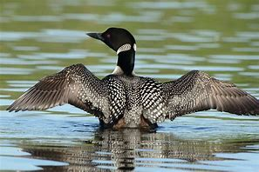

Steven J. Kerr and Dawn Tower-DuBois
Jack Lake Association
December, 2019

This report should be cited as follows: Kerr, S. J. and D. T. DuBois. 2019. A summary of 2019 loon observations on Jack Lake, Peterborough County. 2 p. + appendcies

Cover Photo – Google photo

Introduction
The Canada Lakes Loon Survey was initiated in 1981. It is a volunteer-based program, coordinated by Bird Studies Canada, designed to collect information in order to monitor the status of the common loon (Gavia immer) across Canada.
Jack Lake volunteers have been involved in the Canadian Lakes Loon Survey since 1982 (Kerr et al. 2016). On Jack Lake, loon information is collected in two ways:
- Volunteers submit individual observations throughout the open water period; and
- Two person teams are assigned a lake sector (see map below) and collectively do lakewide surveys during a specified time and date during the months of June, July, August and September.
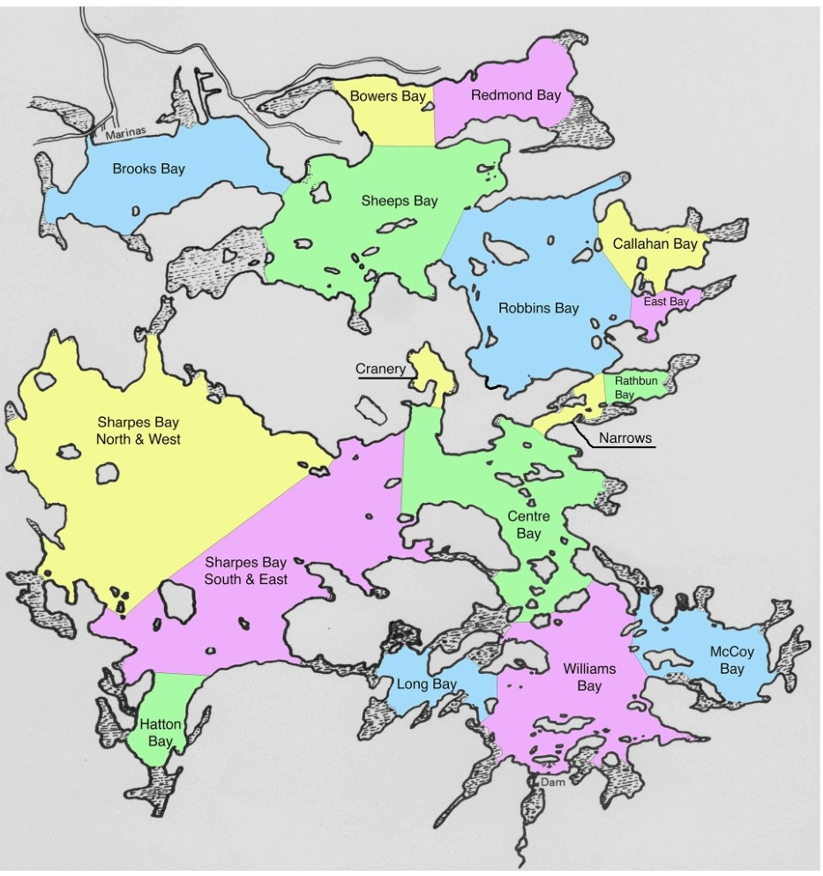
Figure 1. Designated sectors for lakewide loon surveys on Jack Lake.
At the end of the season, these data are collated and a final report is submitted to Bird Studies Canada.
2019 Loon Observations
Four lakewide loon surveys were conducted in 2019 (Table 1).

Table 1. Results of 2019 lakewide loon surveys on Jack Lake.

Survey Date | # of Adult Pairs | # of Young-of-Year | # Single Adults
June 16 | 6 | 0 | 6
July 21 | 7 | 4 | 5
August 25 | 6 | 6 | 12
September 22 | 4 | 9 | 10

The first loon observed on Jack Lake was recorded on April 21 one week before the lake was totally ice-free (April 28). It was estimated that there were seven pair of nesting loons which produced nine young-of-year in 2019 (Table 2). Observed hatching dates occurred in late June. Flocking behaviour was observed on August 20 (11 loons in Williams Bay), September 5 (13 loons in Williams Bay) and September 14 (8 loons in Williams Bay).
Table 2. A summary of key loon observations from Jack Lake in 2019.
Parameter | Observation(s)
Arrival date(s) | Late April
Number of nesting pairs | 7
Reproductive success | 9 young-of-year
Abandoned nests | None observed
Observed hatching date(s) | June 19-30
Loon mortality | None observed
Flocking (pre migration) dates | August 20-September 14
Migration dates | Late November

2019 Loon Survey Volunteer Participants
The 2019 loon survey could not have been completed without the participation of many volunteers. Individuals who participated in lakewide loon counts included (listed alphabetically) Tim Cork, Dennis Davenport, Glady Donnan, Dawn and Bill DuBois, Marcine and Bob DuBois, Lisa and Bill Fischer, Sheelagh Hysenaj, Bill Johnston, Karen and Steven Kerr, Eileen and Doug Moulton, Jean and Jim Perun, Pat Phillips, Susan and Alan Quarry, the Robertson family, Eunice and Guy Speed, Chris and Hugh Spence, and Pat and Victor Ward. Additional loon observations were reported by Frank Cirrina, Brian Currie, Ruth Davenport, Mary Derks, Terry Halcovitch, Todd Hill, Allan Kerr, Ryan Kluake, Mark Kozicki, Denyze Martial, Mario Loeb-McQuaker, Stephanie Tuer, Judy Wager-Kiffer and Christina Welton.

Literature Cited
Kerr, S. J., D. Tower-DuBois and S. Hynenaj. 2016. Review of observations of common loons (Gavia immer) on Jack Lake, 1982-2016. Jack Lake Association. Apsley, Ontario. 11 p.
Appendix 1. Jack Lake Loon Survey observations recorded during 2019.
Year - 2019 Survey Dates – April 21 – November 6 Number of Participants – 43
Date | Time of Day | Location | Loon Observations | Observer(s)
April 21 | Not reported | Center Bay | Several adult loons observed. Photos were taken. Some ice still on the lake | Tim Cork
April 22 | Not reported | Brooks Bay | Ice still on lake | Sheelagh Hysenaj
May 3 | Morning | Williams Bay | One pair of adults was observed | Stephanie Tuer
May 4-5 | Not reported | Rathbun Bay | One single adult was observed | Ruth Davenport
May 11 | Afternoon | Sheeps Bay | One single adult was observed | Mary Derks
May 11 | Afternoon | Sheeps Bay  (School Teachers Island) | One pair of adults was observed. | Mary Derks
May 11 | Not reported | Jackson Bay (northwest corner of Sharpe’s Bay) | One pair of adults was observed. | Ryan Klauke
May 17 | Afternoon | Rathbun Bay | One pair of adults was observed | Allan Kerr
May 19 | Not reported | Brooks Bay  (northwest) | Pair of adults was observed | Sheelagh Hysenaj
May 20 | Not reported | Rathbun Bay | Three adult loons were observed. | Steven Kerr
June 1-2 | Not reported | Brooks Bay (northwest end) | Pair of nesting loons was observed. | Sheelagh Hysenaj
June 5 | Not reported | Rathbun Bay | One adult loon was observed. | Steven Kerr
June 8 | Not reported | Rathbun Bay | Single adult was observed | Karen Burleigh-Kerr
June 15 | Not reported | Redmond Bay  (south) | One pair of adults was observed | Steven Kerr and Neil Lanz
June 16 | Not reported | Center Bay (southeast side of island) | Adult loon observed on it’s nest (photos were taken) | Marcine DuBois
Date | Time of Day | Location | Loon Observations | Observer(s)
June 16 | Morning | Entire Lake | A total of twelve adult loons (6 singles) and two nests were reported. | Numerous volunteers – first lakewide survey of the season.
June 19 | Not reported | Sharpe’s Bay | One pair of adults with a young-of-year (photo was taken). | Christina Welton
June 22 | Not reported | Narrows  (at Johnsons) | One single adult was observed | Steven Kerr and Karen Burleigh-Kerr
June 22 | Not reported | Williams Bay  near dam) | One single adult was observed | Steven Kerr and Karen Burleigh-Kerr
June 22 | Not reported | Long Bay | One single adult was observed | Steven Kerr and Karen Burleigh-Kerr
June 22 | Not reported | Rathbun Bay | One single adult was observed | Steven Kerr and Karen Burleigh-Kerr
June 30 | Not reported | Williams Bay | Pair of adult loons with two young-of-year were (photo was taken). | Mark Kozicki
June 30 | Not reported | Williams Bay  (near dam) | Loon seen on nest near the dam | Ruth Davenport
July 1 | Afternoon | Williams Bay  (at dam) | One pair of adults with two young-of-year were observed  . | Tim Cork
July 1 | Not reported | Brooks Bay | Pair of adult loons observed but no young-of-year. | Sheelagh Hysenaj
July 9 | Not reported | Rathbun Bay | One single adult was observed | Steven Kerr
July 13 | Not reported | Redmond Bay | One adult loon with one young-of-year was observed. | Frank Cirinna
July 15 | Not reported | Center Bay  (near Wagars) | One pari of adults with one young-of-year was pbserved. | Steven Kerr and Karen Burleigh-Kerr
Date | Time of Day | Location | Loon Observations | Observer(s)
July 16 | Not reported | Center Bay | One pair of adults with one young-of-year (YOY) was observed | Allan Kerr
July 17 | Not reported | Wagers Point | Pari of adult loons with YOY chick on adult’s back was observed. | Mary Derks
July 17 | Not reported | Rathbun Bay | One single adult and one pair of adults (not together) were observed. | Arnold Tripp
July 21 | Morning | Entire Lake | Five single adult loons, seven pair of adult loons and four young-of-year loons were observed. | Numerous volunteers – second lakewide survey of the season.
August 1 | Not reported | Center Bay | Pair of adult loons with one large young-of-year were observed. | Steven Kerr and Karen Burleigh-Kerr
August 11 | Not reported | Redmond Bay | One adult loon with one young-of-year. | Frank Cirinna
August 14 | Not reported | Williams Bay | One pair of adult loons and one young-of year were observed. | Brian Currie
August 20 | Morning | McCoy Bay | Eleven adult loons which appeared to move as a group were observed. | -
August 25 | Morning | Entire Lake | Twelve single adult loons, six adult pairs and six young-of-year were observed. | Numerous volunteers – third lakewide survey of the season
September 4 | Afternoon | Williams Bay | One pair of adult loons and one young-of-year were observed (photos were taken). | Mario Loeb McQuaker
September 5 | Morning | Center Bay | Thirteen loons together in a flock were observed (photo was taken). | Judy Wagar Kiffer
September  14 | Not reported | Williams Bay | Eight adult loons were observed in one group | Denyze Martial
September  14 | Not reported | Brooks Bay | Two adult loons were observed | Steven Kerr and Karen Burleigh-Kerr
Date | Time of Day | Location | Loon Observations | Observer(s)
September  14 | Not reported | Rathbun Bay | One single adult was observed | Steven Kerr and Karen Burleigh-Kerr
September  14 | Not reported | East Bay | One single adult was observed | Steven Kerr and Karen Burleigh-Kerr
September  16 | Not reported | Narrows | One large young-of-year was observed | Steven Kerr
September  16 | Not reported | Williams Bay | One pair of adults was observed. | Steven Kerr
September  16 | Not reported | Sheeps Bay | One pair of adults was observed | Steven Kerr
September  16 | Not reported | Williams Bay | One adult with one young-of-year were observed | Steven Kerr
September  20 | Not reported | Callahan Bay | One pair of adult loons was observed. | Steven Kerr
September  20 | Not reported | Sheeps Bay | One pair of adult loons was observed | Steven Kerr
September  20 | Not reported | Centre Bay | One adult loon with one young-f-the-year | Steven Kerr
September  22 | Morning | Entire Lake | 10 single adults, four adult pairs and 9 young-of-year were observed | Numerous volunteers – fourth and final lakewide survey of season
September  27 | Evening | Centre Bay | One single large young-of-year was observed. | Steven Kerr and Karen Burliegh-Kerr
September  28 | Afternoon | Rathbun Bay | One pair of adult loons was observed. | Steven Kerr and Karen Burleigh-Kerr
September  28 | Afternoon | Brooks Bay | One single large young-of-year observed. | Steven Kerr and Karen Burleigh-Kerr
September  28 | Afternoon | Sheeps Bay | One pair of adults was observed. | Steven Kerr and Karen Burleigh-Kerr
September  28 | Afternoon | Redmond Bay  (south end) | One single adult loon observed. | Steven Kerr and Karen Burleigh-Kerr
Date | Time of Day | Location | Loon Observations | Observer(s)
September  28 | Evening | Rathbun Bay | One single large young-of-year was observed. | Steven Kerr
October 4 | Afternoon | Centre Bay | One single large young-of-year was observed. | Steven Kerr
October 11 | Late Afternoon | Rathbun  Bay | One single large young-of-year was observed. | Steven Kerr and Karen Burleigh-Kerr
October 11 | Late Afternoon | Centre Bay | One single large young-of-year was observed. | Steven Kerr and Karen Burleigh-Kerr
October 11 | Late Afternoon | Sharpe’s Bay (northeast) | Two large young-of-year were observed | Steven Kerr and Karen Burleigh-Kerr
October 12 | Afternoon | Rathbun Bay | One single large young-of-year observed. | Steven Kerr and Karen Burleigh-Kerr
October 12 | Afternoon | Brooks Bay | One single large young-of-year was observed. | Steven Kerr and Karen Burleigh-Kerr
October 20 | Afternoon | Robbins Bay | One single large young-of-year was observed. | Allan Kerr
October 20, | Afternoon | Sheeps Bay | One single large young-of-year was observed. | Allan Kerr
October 20 | Afternoon | Brooks Bay | One single large young-of-year was observed. | Allan Kerr
October 28 | Morning | Long Bay | One single large young-of-year was observed. | Steven Kerr and Dennis Davenport
October 28 | Morning | Center Bay  (Casement Island) | Three large young-of-year observed | Glady Donnan
October 28 | Afternoon | Rathbun Bay | One single large young-of-year was observed. | Steven Kerr and Dennis Davenport
October 28 | Afternoon | Robbins Bay | One single large young-of-year was observed. | Steven Kerr and Dennis Davenport
November 4 | Not reported | Sheeps Bay | One single large young-of-year was observed. | Terry Halcovitch
November 6 | Not reported | Robbins Bay | One single large young-of-year was observed. | Todd Hill
Date | Time of Day | Location | Loon Observations | Observer(s)
November 7 | Nor reported | Redmond Bay | One single large young-of-year was observed. | Todd Hill
November 7 | Not reported | Sharpes Bay  (northwest) | One single large young-of-year was observed.  Photo was taken. | Ryan Kluake
November 9 | Not reported | Narrows | One single large young-of-year was observed. | Todd Hill
November 10 | Nor reported | Sharpes Bay | One single large young-of-year was observed. | Pat Phillips
November 20 | Morning | Sharpes Bay | One single large young-of-year was observed. | Christina Welton

