Results of the 2020 Turtle Tally on
Jack Lake

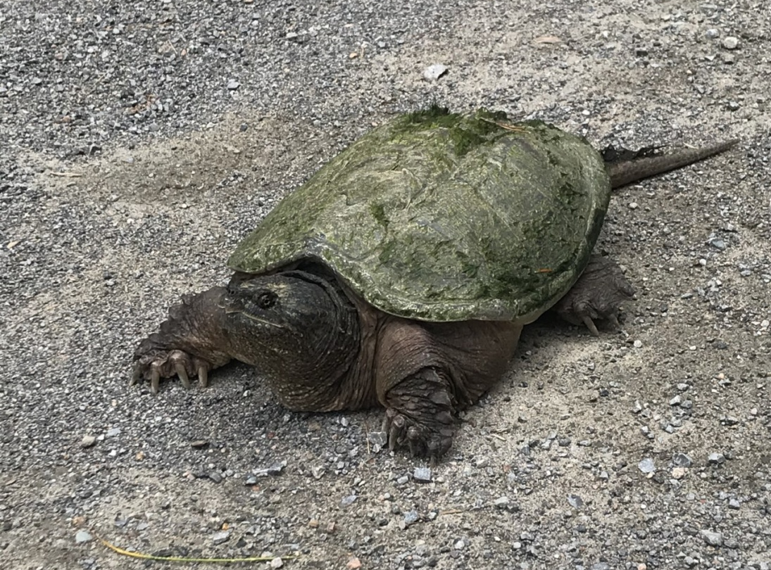

Steven J. Kerr
Jack Lake Association
November, 2020

Introduction
There are 8 species of turtle in Ontario. Six of these species are found in the Jack Lake watershed (Table 1). All six of these species have been designated as species at risk.
Table 1. Federal and provincial designation of turtles in Ontario.
Species | Provincial Designation | Federal Designation
Blandings Turtle | Threatened | Endangered
Eastern Musk Turtle | Special Concern | Special Concern
Midland Painted Turtle | Not Listed  (Yet to be Assessed) | Special Concern
Northern Map Turtle | Special Concern | Special Concern
Snapping Turtle | Special Concern | Special Concern
Spotted Turtle | Endangered | Endangered

The first turtle observations from Jack Lake were recorded in 1987 (Table 2). In 2014, a more concerted effort was initiated to collect more information on turtle distribution and abundance in the Jack Lake area (see Kerr 2016, 2017, 2018 and 2019).
Table 2. Turtle observations from the Jack Lake area, 1987- 2019.
Number of Specimens Observed and Reported
Year | # of Participants | Blandings  Turtle | Eastern Musk Turtle | Midland Painted  Turtle | Northern  Map Turtle | Snapping  Turtle | Spotted Turtle | Unidentified
1987 | - | - | - | - | - | 1 | - | -
1988 | - | - | - | 1 | - | 1 | - | -
1994 | - | - | - | - | - | 1 | - | -
1999 | - | - | - | 1 | - | - | - | -
2007 | - | 1 | - | 1 | - | 2 | - | -
2008 | - | 1 | - | 1 | - | 2 | - | -
2009 | - | 1 | - | 8 | - | 2 | - | -
2010 | - | 4 | - | 8 | - | - | - | -
2011 | - | 3 | - | 3 | - | - | - | -
2012 | - | 2 | - | 2 | - | 5 | - | -
2013 | - | 1 | - | 7 | - | 5 | - | -
2014 | 5 | 2 | - | 32 | - | 12 | - | -
2015 | 6 | 3 | - | 58 | - | 20 | - | -
2016 | 17 | 5 | - | 14 | - | 16 | - | -
2017 | 31 | 6 | - | 60 | 2 | 21 | - | -
2018 | 33 | 7 | - | 43 | 6 | 34 | - | 1
2019 | 30 | 11 | 1 | 51 | 4 | 17 | 1 | 3

2020 Turtle Observations
A total of 70 individual turtles were reported during the 2020 season. The majority of turtle observations occurred during the nesting period in May and June (Table 3).
Table 3. Temporal distribution of 2020 turtle observations from the Jack Lake watershed.
Turtle Species | April | May | June | July | August | September-October | Total
Blandings Turtle | 0 | 2 | 2 | 0 | 0 | 0 | 4
Eastern Musk Turtle | 0 | 1 | 0 | 0 | 0 | 0 | 1
Midland Painted Turtle | 1 | 23 | 19 | 4 | 1 | 0 | 48
Northern Map Turtle | 0 | 3 | 0 | 0 | 0 | 0 | 3
Snapping Turtle | 0 | 2 | 9 | 1 | 1 | 0 | 13
Spotted Turtle | 0 | 0 | 0 | 0 | 0 | 0 | 0
Unknown | 0 | 0 | 1 | 0 | 0 | 0 | 1
2020 Summary | 1 | 31 | 31 | 5 | 2 | 0 | 70

The first turtle observation was reported on April 25. Perhaps one of the most significant observations in 2020 was a report of 18 midland painted turtles basking in the Centre Bay area on May 3. At least ten turtles were reportedly moved off a road in 2020.
Table 4. Highlights of the 2020 Jack Lake Turtle Tally.
Number of Participants | 20
Number of Turtles Observed
Blandings Turtle | 4
Eastern Musk Turtle | 1
Midland Painted Turtle | 48
Northern Map Turtle | 3
Snapping Turtle | 13
Spotted Turtle | 0
Unknown | 1
2020 Summary | 70

Acknowledgements
This program would not be possible without the contributions of many enthusiastic volunteers who included (listed alphabetically): Daryl Aitken, Shelli Baltman, Heather Bee, Gerald Blackstock, Karen Burleigh-Kerr, Paul Campbell, Tim Cork, Ruth Davenport, Mary Derks, Ralph Dunham, Todd Hill, Mike Jensen, Rob Johnson, Allan Kerr, Steven Kerr, Alex Kostiw, Selena Leger, Mario Loeb, Kristy Maguire, and Sam McKenzie,

References
Kerr, S. J. 2016. Turtle observations from the Jack Lake watershed, 2014-2016. Report prepared for the Jack Lake Association. Apsley, Ontario. 2 p. + appendices. https://www.jackslakeassociation.ca/assets/conserve/2014-2016%20Turtle%20Observations%20in%20the%20Jack%20Lake%20Area%20%28Final%29.pdf
Kerr, S. J. 2017. 2017 turtle observations in the Jack Lake watershed. Report prepared for the Jack Lake Association. Apsley, Ontario. 4 p. + appendices. https://www.jackslakeassociation.ca/assets/key%20Documents/2017%20Turtle%20Observations%20in%20the%20Jack%20Lake%20Watershed.pdf
Kerr, S. J. 2018. 2018 turtle observations from the Jack Lake watershed. Report prepared for the Jack Lake Association. Apsley, Ontario. 3 p. + appendices. https://www.jackslakeassociation.ca/assets/key%20Documents/2018%20Turtle%20Observations%20from%20the%20Jack%20Lake%20Watershed.pdf
Kerr, S. J. 2019. 2019 turtle observations from the Jack Lake area. Report prepared for the Jack Lake Association. Apsley, Ontario. 3 p. + appendices. https://www.jackslakeassociation.ca/assets/key%20Documents/2019%20Turtle%20Observations%20from%20the%20Jack%20Lake%20Watershed.pdf

Websites
https://ontarioturtle.ca/
https://cottagelife.com/outdoors/how-to-identify-ontarios-8-species-of-turtles/
https://animals.mom.me/kinds-turtles-live-canada-10423.html

Appendix 1. Individual turtle observations recorded in the Jack Lake area during 2020.
Date | Turtle Species | Observer(s) | Site/Location | Details
April 25 | Midland Painted  Turtle | Ruth Davenport | End of East Bay | Turtle basking on a log.  Photo taken.
May 3 | Midland Painted  Turtle | Ralph Dunham | Pond off Centre Bay | Eighteen turtles observed basking on logs.  Photos taken.
May 11 | Blandings  Turtle | Alex Kostiw | Jack Lake Road | Turtle was moved off the road.
May 15 | Eastern Musk Turtle | Todd Hill | Hwy 28  (near Apsley) | Approximately ten inches in length.
Mid May | Snapping  Turtle | Alex Kostiw | Jack Lake Road | Turtle was moved off the road.
May 16 | Snapping Turtle | Rob Johnson | Dam at the outlet | Photos taken.
May 17 | Midland Painted Turtle | Ruth Davenport | Griggs Island | Four turtles on a log.  Photos taken.
May 17 | Northern Map Turtle | Ruth Davenport | Griggs Island | Two turtles on a log.  Photo taken.
May 18 | Blandings Turtle | Sam McKenzie | McCoy Road  (near Hwy 504) | Photos taken.
May 23 | Northern Map Turtle | Ruth Davenport | Sharpe’s Bay | Photo taken.
Late May | Midland Painted Turtle | Tim Cork | Centre Bay (west) | One ten inch long turtle on the driveway.
Early June | Midland Painted Turtle | Tim Cork | FR89 | One six inch turtle moved off the road.  One eight inch turtle moved off the road (different site).
June 9 | Blandings Turtle | Mary Derks | Sheeps Island | Turtle laid eggs on lawn in the morning.
June 9 | Midland Painted Turtle | Ruth Davenport | McCoy Road | Approximately 4 inches in length.
June 9 | Midland Painted Turtle | Heather Bee | Jack Lake Road | Turtle was moved off the road.
June 9 | Midland Painted Turtle | Heather Bee | FR50 | Two turtles observed.
Date | Turtle Species | Observer(s) | Site/Location | Details
June 9 | Midland Painted Turtle | Heather Bee | Hatton Bay wetland | -
June 11 | Snapping Turtle | Kristy Maguire | Not reported | Turtle was in the water.  Photo taken.
June 11 | Midland Painted Turtle | Kristy Maguirre | McCoy Road (FR85A) | -
June 11 | Midland Painted Turtle | Kristy Maguire | McCoy Road  (FR85) | -
June 11 | Snapping Turtle | Kristy Maguire | McCoy Road  (FR85) | -
June 12 | Midland Painted Turtle | Kristy Maguire | Not reported | Photo taken.
June 12 | Snapping Turtle | Kristy Maguire | Not reported | Photo taken.
June 14 | Blandings Turtle | Karen and Steven Kerr | McCoy Road (near Hwy 504) | Large specimen was moved off the road.
June 14 | Midland Painted Turtle | Gerald Blackstock | FR50 | Photo taken.
June 14 | Midland Painted Turtle | Tim Cork | Centre Bay (west) | Turtle was observed laying eggs on the driveway.  Approximately 6 inches in length.
Mid June | Midland Painted Turtle | Tim Cork | FR89 | Two nine inch long turtles moved off the road (at different sites)
Mid June | Midland Painted Turtle | Tim Cork | Centre Bay (west) | One eight inch turtle observed in the water off the dock.
June 17 | Snapping Turtle | Shelli Baltman | Jack Lake Road (near Jack Lake Lodge) | Turtle was laying eggs.  Photo taken.
June 17 | Snapping Turtle | Mary Derks | Sheeps Bay | Turtle was laying eggs.  Photo taken.
June 18 | Midland Painted Turtle | Tim Cork | Small bay at the Narrows | Approximately eight inches in length.
Date | Turtle Species | Observer(s) | Site/Location | Details
June 22 | Snapping Turtle | Paul Campbell | Sheeps Bay | Nesting on volleyball court.  Photo taken.
June 21 | Snapping Turtle | Daryl Aitken | East Bay  (north shore) | Large specimen.
June 21 | Snapping Turtle | Mike Jensen | Williams Bay  (Island 7) | Turtle was observed in the water near the dock.
June 23 | Midland Painted Turtle | Mary Derks | Sheeps Bay | Photo taken.
June 26 | Midland Painted Turtle | Tim Cork | Narrows | Two turtles, each approximately 8 inches in length, on a log.
June 30 | Unidentified | Selena Leger | McCoy Road wetland. | Turtle basking on a log.
June 30 | Snapping Turtle | Steven Kerr and Karen Burleigh-Kerr | Rathbun Bay  (north shore) | Large specimen in water at dock.
Early July | Midland Painted Turtle | Susan Quarry | Sharpe’s Bay | Three turtles observed basking.
July 1 | Snapping Turtle | Selena Leger | McCoy Road | Small turtle moved off the road.
July 30 | Midland Painted Turtle | Mario Loeb | Sharpe’s Bay | Small turtle.
August 20 | Snapping Turtle | Allan Kerr | Rathbun Bay  (north shore) | Large specimen in water at dock.
August 23 | Midland Painted Turtle | Steven Kerr | Hwy 504 (near McCoy Road turnoff) | Turtle was moved off the road.

